**PROJECT REPORT**

|  |  |  |  |  |
| --- | --- | --- | --- | --- |
| **PROJECT NAME** | **Mern Blogging Site** | **Group NO.** | **03** | |
| **Course Code** | **Group Members (Name & ID)** | **Date of Submission** | **% Completion of Project (Approx.)** |
| CSE434 | Md. Jim Ar Rafi (181400083) A.S.M Imrul Kayes (181400103) Raihan Munim (181400138) | Jan 9th 2022 | 100 % |

**PROJECT INTRODUCTION**

|  |
| --- |
| The main objective of our project was to create a blogging platform where anyone can share their valuable information and ideas as easily as possible. That prompted us to make a easy to use Mern Blogging site. For someone to share information, all they need to do is register an account with their email address and an unique username and password. Then they can login, create/update their profile information. In case they want to share anything, they can go to the homepage and click the Write link, that redirects the user to the create a post page where they can create a post with the information, add images, tiles and description. He/She has the option to edit the post, but he/she can only edit theirs, it is determined through their postId’s. All the posts gets categorised and displayed accordingly. Anyone can view these posts without an account but to interact/add posts they have to register an account. There are no limits on how many post a user can create. Users can search posts using usernames, or categories.  The project was divided into three sections, the user interface/design part, the rest api using node.js and mongo db, and the part where the UI gets connected with the REST API. |

**TECHNICAL DETAILS**

|  |
| --- |
| **MongoDB** has been used as the database for this project  Languages Used: **Html, CSS, JavaScript, Node.js** |

**Project Demonstration Link**

|  |
| --- |
| **Project link:** |

**PROJECT OVERVIEW**

|  |  |  |  |  |
| --- | --- | --- | --- | --- |
| **Modules/  Sub-parts** | **Use Cases** | **Details** | **Completion Status (Y/N)** | **CONTRIBUTORS** |
| User Interface | Register | Where the user registers | Y | Md. Jim Ar Rafi (181400083) |
| Login | Where the user logs in user username/password | Y |
| Home | This is the home page where users can navigate to | Y |
| Settings | UI related settings | Y |
| Write | Where the user can writes posts | Y |
| Posts | Where the posts are found | Y |
| Rest API | Express server | Provides server-side log for website | Y | Raihan Munim (181400138) |
| Register and Login routes | Connect to database and create/update new accounts | Y |
| Update/Delete Users | Can update/delete from database | Y |
| Create post | Connect to datatbase for interactions with Information and images | Y |
| Delete/Update posts | Can update/delete post from database | Y |
| Add new categories | Add categorical information in database | Y |
| Filter queries | Fetch everything with conditions from db | Y |
| Upload route | To upload images | Y |
| Connecting the two components | Home Page | Fetch data from mongoDB and display | Y | A.S.M Imrul Kayes (181400103) |
| Fetch posts | When clicked it fetches posts with post ID, or can be fetched using username or category | Y |
| Register and login | Connected the UI with the REST API, now users can register and login. | Y |
| Write | Users can create posts by clicking this, use pictures, tiltle, descriptioin. | Y |
| Edit/Delete Post | User can only edit and delete their posts. | Y |
| Click on Profile | Here the user can, edit or their delete their account. | Y |
| Logut | Here the user can log out of their account. | Y |

**Project Diagrams**

* **Use Case Diagram:**

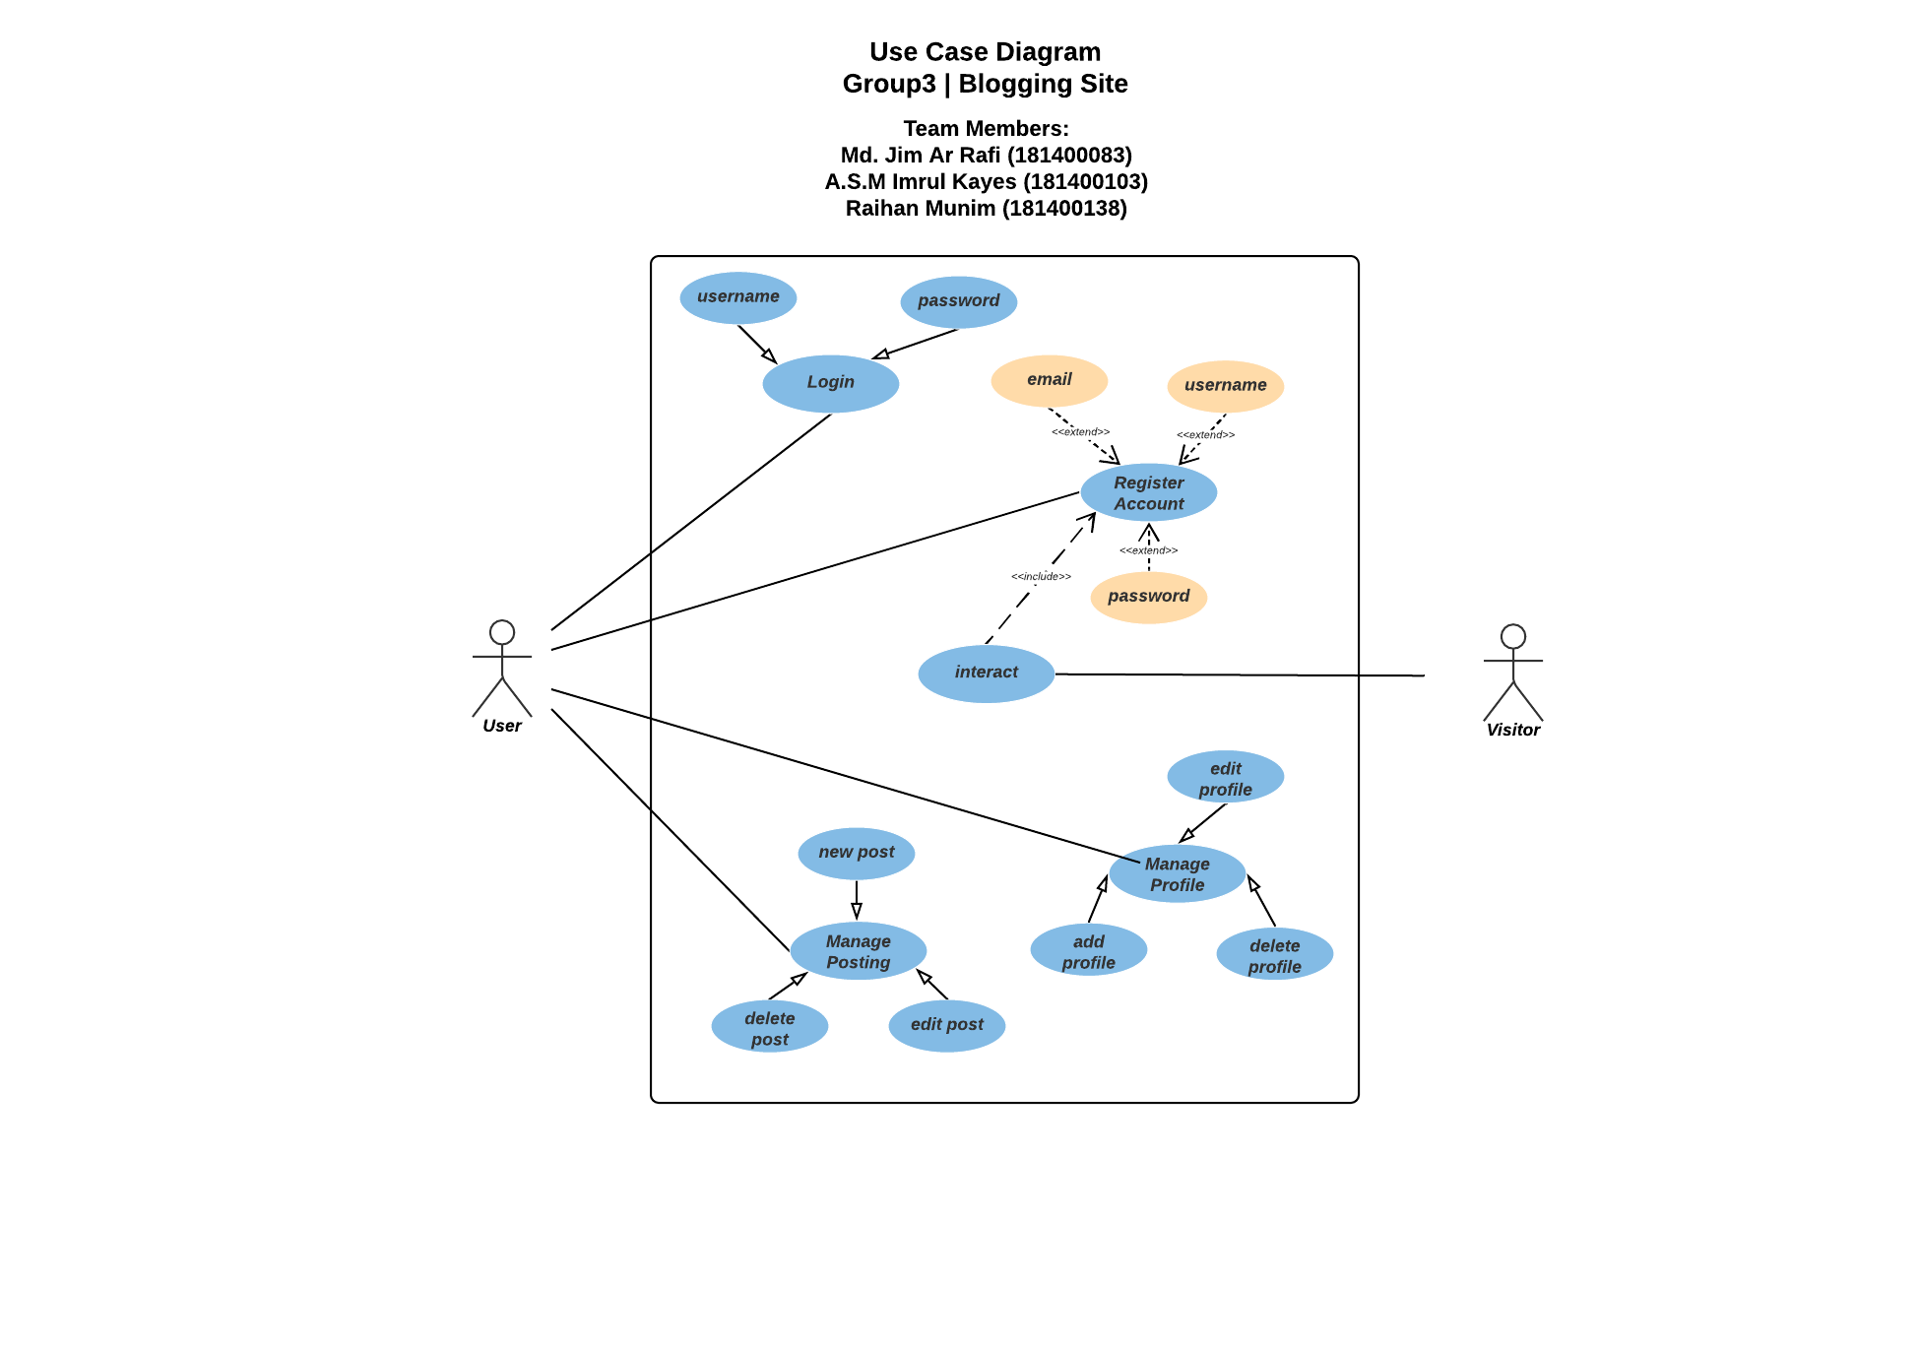

* **Data Flow Diagram:**

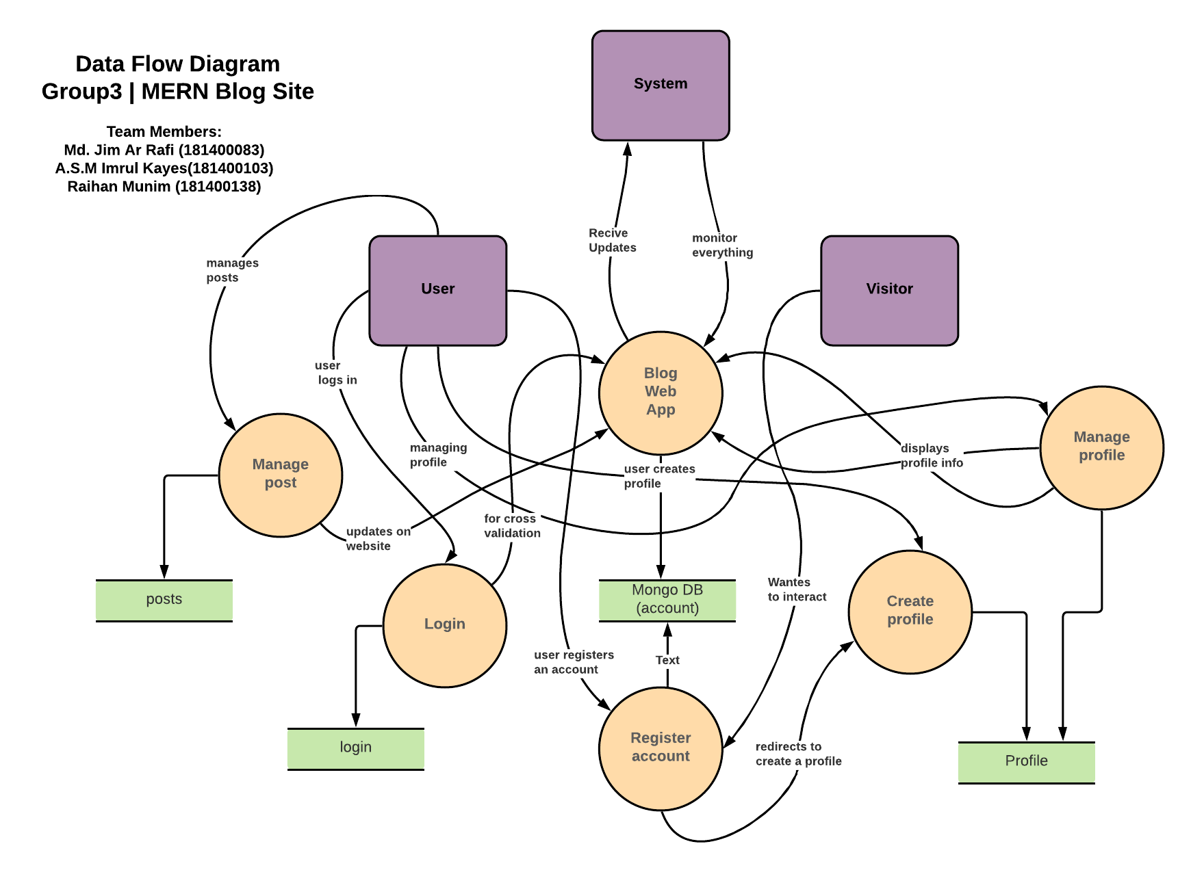

**ER Diagram:**

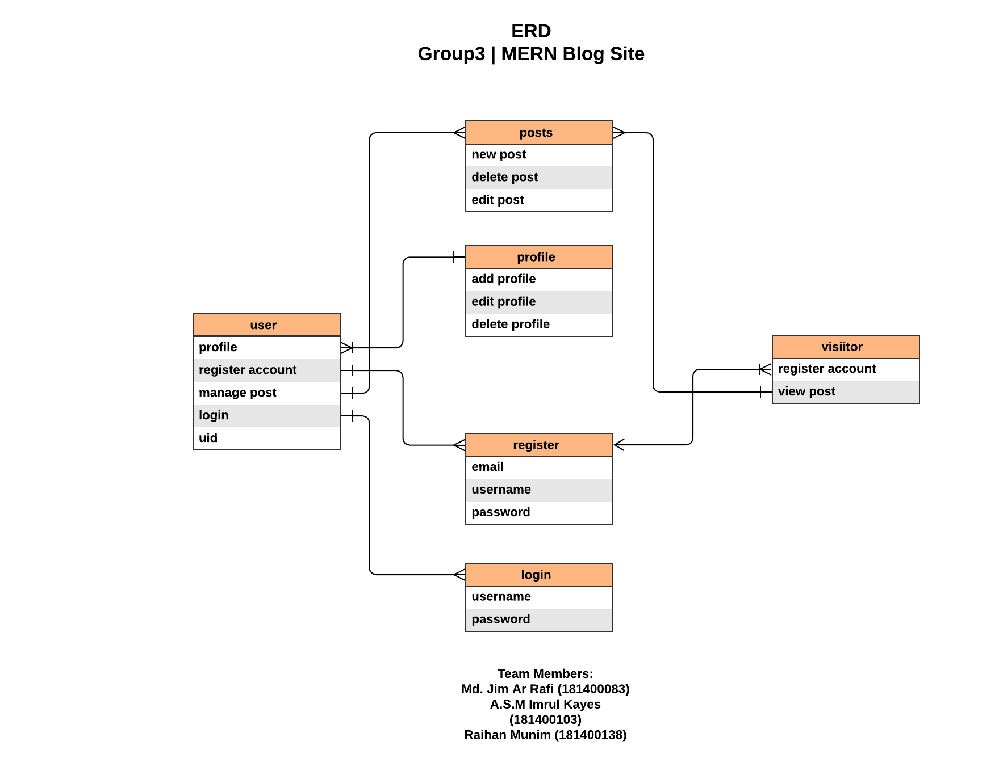

**Snapshots:**

**User Interface:**

**Register Page**

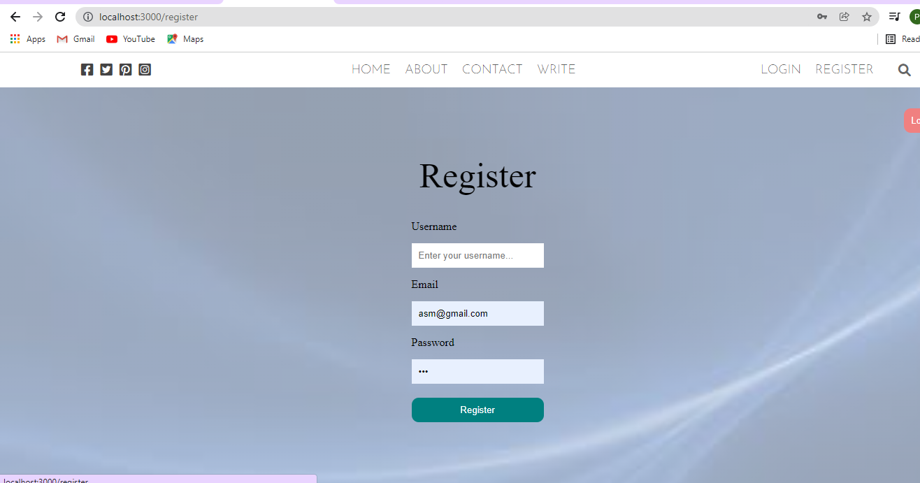

This is the register page where the user can register an account using username, email and a password. Three of the requirements has to be unique and valid.

**Login Page**

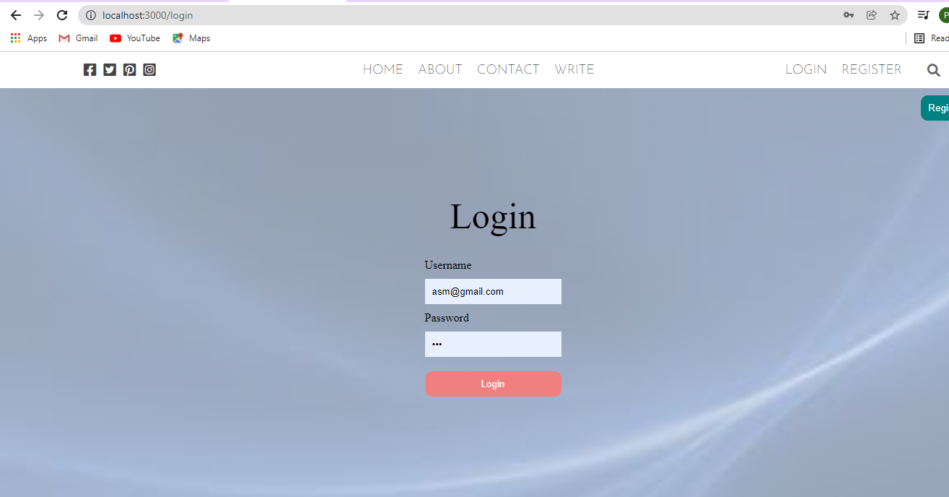

Here the user will login to their account using the username and password provided during registering an account.

**Home Page**

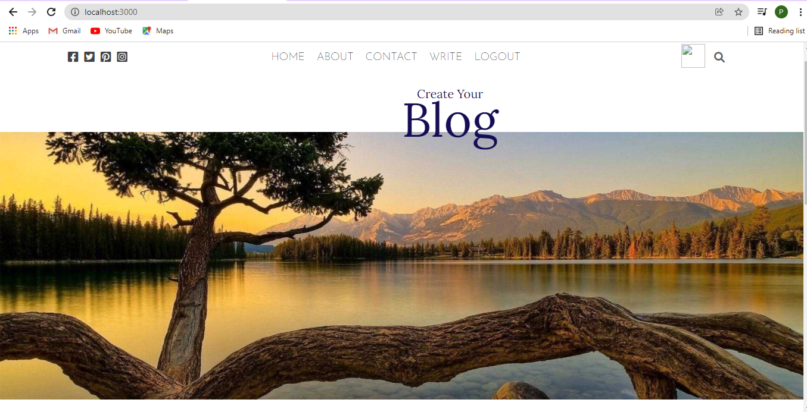

This is the home page, here the user can navigate to the other pages.

**Update account**

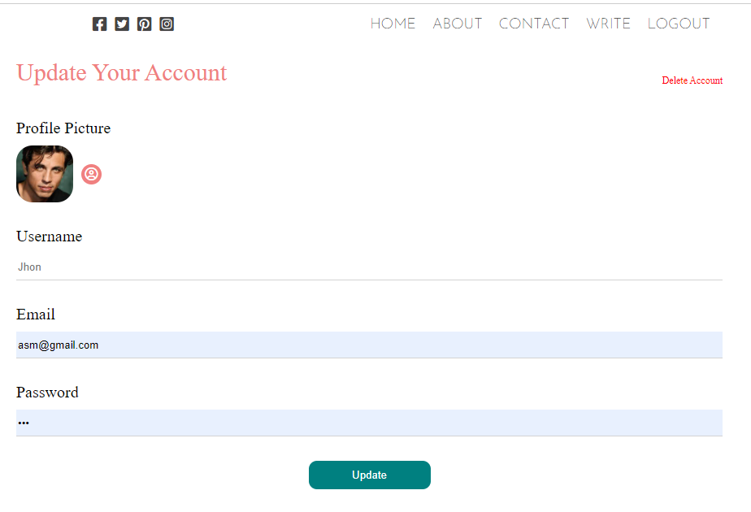

Update page can be accessed by clicking the profile image. The user can only update/delete their information.

**Writing a blog/post**

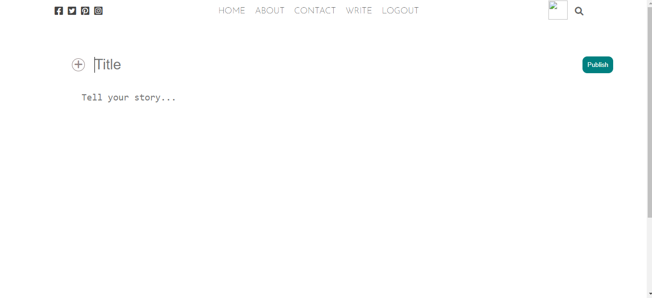

This is the write page, where the user can write the post, add images, title, and a description and then publish.

Published blog/post

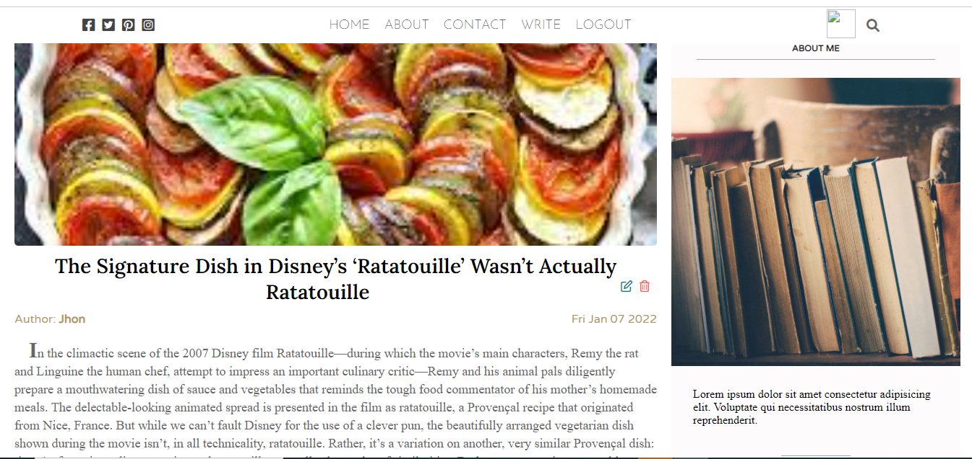

This is what the published post will look like, here the user can update or delete it. Other users won’t be able to change anything here.

REST API using MongoDB

Tool used: Postman to test queries.

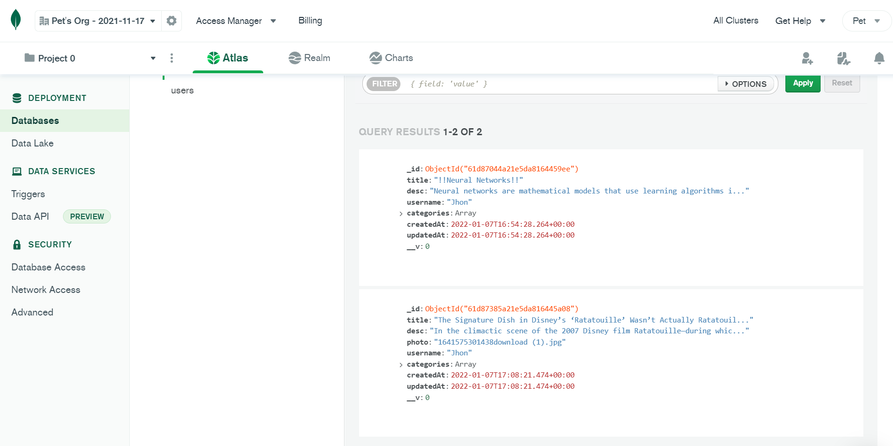

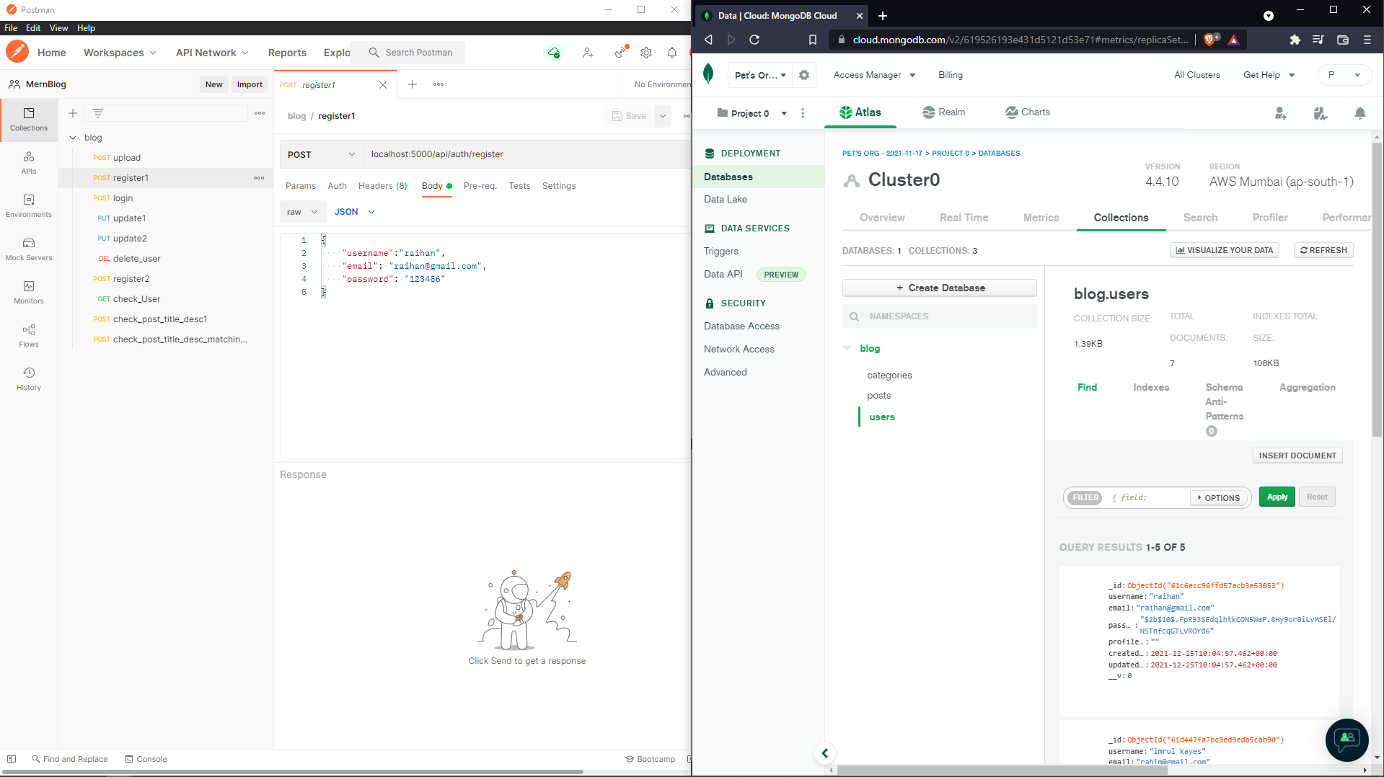

Above: The MongoDB and below are the tested queries on the database